# Laser ToF Sensor

# Introduction

The purpose of this document is to describe the Laser Time of Flight (ToF) Sensor block of the Wearable Sensor for the Blind ECE Senior Capstone Project to other engineers with enough detail such that they would be able to reproduce and test this block using only this document as reference. The Laser ToF block is implemented using a band of many VL53L0X ToF Ranging Sensor from ST Microelectronics on custom-built PCBs. Included in this document are an overview of the block, a schematic and wiring diagram, the properties of the interfaces with the other blocks in the system and testing procedures for each, and reasoning for why this design is the best solution for this block.

# Block Overview

The Laser ToF Sensor block will provide the distance to the nearest object in eight 45° zones around the user to the system, which will use that information to set the system haptic feedback module that will convey that distance information to the user. The measurements taken need to be fast and accurate, so that the user can quickly and confidently navigate around obstacles in their environment. Fig. 1 below shows the black box diagram of the system. *otsd_lsr_tf_snsr_envin* represents the environmental input to this block, namely the distance to the nearest objects. *lsr_tf_snsr_cntrllr_cd_data* represents the I2C input from the microcontroller, which triggers measurements for the sensors and programs the ranging profile. *pwr_spply_lsr_tf_snsr_dcpwr* represents the connection to the power supply, which is regulated to 3.3V, and should draw about 30mA per sensor during measurements. And finally, *cntrllr_cd_lsr_tf_snsr_data* represents the I2C data output from this block to the microcontroller. All the properties for these interfaces can be found in Table I. Sean Sylwester completed this block.

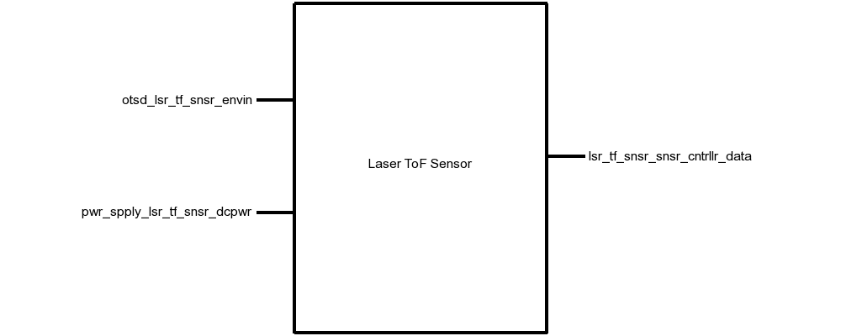

# Fig. 1. Black Box Diagram of the Laser ToF Sensor Block

# Table I. Laser Tof Sensor Block Interfaces And Properties

| **Name** | **Properties** |
| --- | --- |
| *otsd_lsr_tf_snsr_envin* | 1. Other: Accuracy: 12% 2. Other: Range: 0.4m(Black) 1m(White) 3. Other: Angle: 5° 4. Other: Measurement Time: 60ms |
| *lsr_tf_snsr_snsr_cntrllr_data* | 1. Datarate: 100kHz 2. Messages: Address Programming, Measurement Trigger, Measurement Read 3. Other: Measurement Time: 60ms 4. Protocol: I2C |
| *pwr_spply_lsr_tf_snsr_dcpwr* | 1. Inominal: 35µA ± 10% per sensor (between measurements) 2. Ipeak: 30mA per sensor (during measurement) 3. Vmax: 3.5V 4. Vmin: 2.6V |

# Verification

This section details the testing procedures to verify every property listed in Table I. All tests must be passed successfully before this block will be integrated into the rest of the system. Testing will be completed using a single VL53L0X sensor board.

## Power and Communication Testing

This test will verify the power requirements for this block on the *pwr_spply_lsr_tf_snsr_dcpwr* interface, and the communication requirements on the *cntrllr_cd_lsr_tf_snsr_data* and *lsr_tf_snsr_cntrllr_cd_data* interfaces.

1. Connect a VL53L0X sensor to a DC power supply that can display current, set to 2.6V, via the *pwr_spply_lsr_tf_snsr_dcpwr* interface.
2. Connect a microcontroller using I2C at 100kHz to the *otsd_lsr_tf_snsr_envin* interface.
3. Load a test program on the microcontroller than takes a measurement for 200ms, then idles for 200ms.
4. Note the current displayed on the DC power supply during a measurement, and during idle.
5. Repeat steps 1-4 with the DC power supply set to 3.5V.

PASS: This test passes if the current draw never exceeds 30mA, and if the I2C interface communication links at 100kHz.

[Link to Video](https://drive.google.com/open?id=1DZrGBg1QwSPyPH-QyeYReq4xZ42xtdXK)

## Measurement

This test will verify the measurement requirements for this block on the *otsd_lsr_tf_snsr_envin* interface.

1. Connect a VL53L0X sensor to a DC power supply set to 3.3V via the *pwr_spply_lsr_tf_snsr_dcpwr* interface.
2. Connect a microcontroller using I2C at 100kHz to the *otsd_lsr_tf_snsr_envin* interface.
3. Load a test program on the microcontroller than takes a measurement for 60ms, then prints out the distance measurement, then idles for 40ms.
4. Place a white object 1m directly in front of the sensor and note if the sensor detects the object.
5. Place a black object 0.4m directly in front of the sensor and note if the sensor detects the object.
6. Place a white object 30cm away, and 3cm off-center (5°) and note if the sensor detects the object.
7. Place a white object 30cm directly in front of the sensor and note if the distance measurement is within 10% of 30cm.

PASS: If the measurements complete in less than 60ms, objects in steps 4, 5, and 6 were detected, and the object in step 7 was detected within 10%.

[Link to Video](https://drive.google.com/open?id=1DZrGBg1QwSPyPH-QyeYReq4xZ42xtdXK)

# Design

The schematic in Fig. 2 presents this block’s wiring diagram, including the interfaces of this block to the rest of the system. Fig. 3 shows the schematic for the custom-build sensor interface PCB, and Fig. 4 shows the physical layout of this PCB.

This block is implemented using 30 VL53L0X Laser ToF Sensors mounted on a headband to achieve the 360° sensing system requirement. All the sensors are connected to the same I2C (SDA and SCL) bus. Since all the sensors have the same default I2C address on startup, they need to be enabled one-at-a-time to reprogram each address to be unique. This is done with a MAX6895 Delay IC, which propagates a boot signal through each sensor in turn with a 30ms delay. In the 30ms window after a sensor boots, that sensor will be the only one on the I2C bus with the default address, so it can be reprogramed without any conflict.

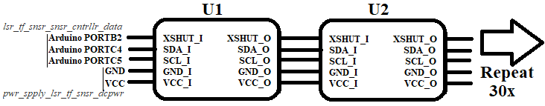

Fig. 2. Wiring Diagram for the Laser ToF Sensor Block

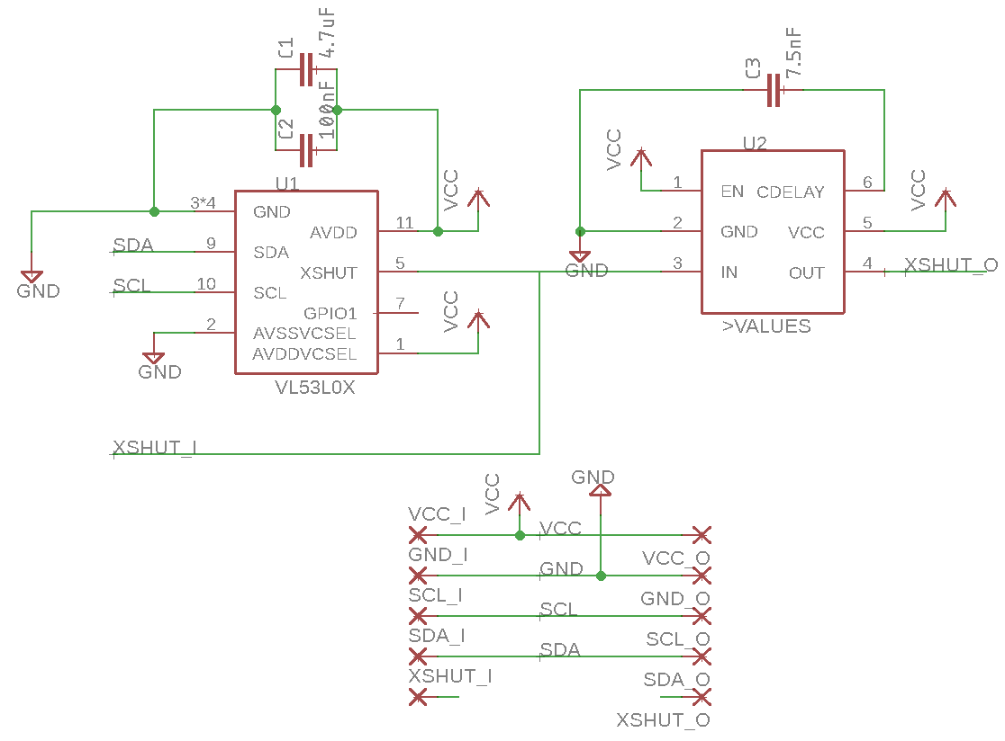

Fig. 3. VL53L0X Interface PCB Schematic

The values for smoothing capacitors C1 and C2, 4.7µF and 100nF, respectively, were indicated in Figure 3 in the VL53L0X datasheet [8]. Capacitor C3 was chosen to set the delay of the MAXIM Delay IC to be 30ms, which was calculated using the equation tDELAY = [CCDELAY x 4.0 x 106 + 40µs] from page 7 of the MAX6895 datasheet [9].

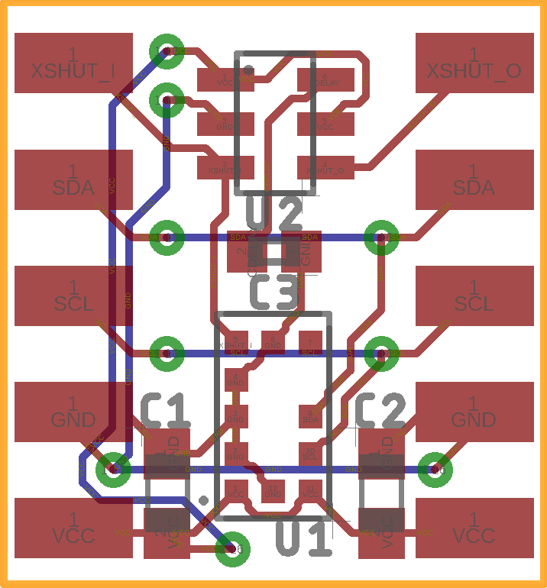

Fig. 4. VL53L0X Interface PCB Layout

## Design Validation

For this block, the VL53L0X sensor was used because it fits the low cost, low power, medium range, high accuracy, and fast performance that this project required of the Laser ToF Sensor block. Table II below validates all the system properties using the VL53L0X Datasheet.

Table II. Interface Property Validation For The Laser ToF Sensor Block

| Property | Validation |
| --- | --- |
| *otsd_lsr_tf_snsr_envin* | |
| **Other:** Accuracy: 12% | Table 12 of the VL53L0X Datasheet states that the worst-case accuracy is 12% [8]. |
| **Other:** Range: 0.4m(Black) 1m(White) | Table 11 of the VL53L0X Datasheet states that the minimum range indoors is 1.2m for a white object, and 0.7m for a grey object [8]. |
| **Other:** Angle: 5° | VL53L0X Datasheet states that the FOV of the sensor is 25° [8]. |
| **Other:**Measurement Time: 60ms | Table 13 of the VL53L0X Datasheet states that minimum timing budget is 20ms [8]. |
| *lsr_tf_snsr_snsr_cntrllr_data* | |
| **Datarate:**100kHz | Table 3 of the VL53L0X Datasheet states that the maximum I2C operating frequency is 400kHz [8] |
| **Messages:** Address Programming, Measurement Trigger, Measurement Read | Section 2 of the VL53L0X Datasheet states that Address Programming, Measurement Trigger, and Measurement Read commands can be sent over I2C [8]. |
| **Other:** Measurement Time:60ms | Table 13 of the VL53L0X Datasheet states that minimum timing budget is 20ms [8]. |
| **Protocol:** I2C | Section 3 of the VL53L0X Datasheet states that I2C is the control interface required [8]. |
| *pwr_spply_lsr_tf_snsr_dcpwr* | |
| **Inominal:**35µA ± 10% per sensor (between measurements) | Table 9 of the VL53L0X Datasheet states that the inter-measurement current consumption is 16µA [8]. |
| **Ipeak:**30mA per sensor (during measurement) | Table 9 of the VL53L0X Datasheet states that the measurement current consumption is 19mA [8]. |
| **Vmin:**2.6V | Table 9 of the VL53L0X Datasheet states that the minimum operating voltage is 2.6V [8]. |
| **Vmax:**3.5V | Table 9 of the VL53L0X Datasheet states that the minimum operating voltage is 3.5V [8]. |

## Bill of Materials

Table III. Bill of Materials for the Laser ToF Sensor Block

|  |  |  |  |  |  |  |
| --- | --- | --- | --- | --- | --- | --- |
| **Reference Designator** | **Value** | **Manufacturer** | **Manufacturer Part Number** | **Suppliers** | **Quantity** | **Unit**  **Price** |
| C1 | 4.7uF | Taiyo Yuden | LMK107BJ475KA-T | Mouser | 30 | $0.18 |
| C2 | 100nF | Vishay | VJ0603Y104KXXCW1BC | Mouser | 30 | $0.12 |
| C3 | 7.5nF | Murata | GRM155R71E752JA01D | Mouser | 30 | $0.10 |
| U1 | VL53L0X | STMicroelectronics | VL53L0CXV0DH/1 | Mouser | 30 | $5.30 |
| U2 | MAX6895  Delay IC | MAXIM | MAX6895AAZT+T | Mouser | 30 | $2.00 |

1. STMicrolectronics, “World smallest Time-of-Flight ranging and gesture detection sensor,” VL53L0X datasheet, May 2016
2. MAXIM, “Ultra-Small, Adjustable Sequencing/ Supervisory Circuits,” MAX6895–MAX6899 datasheet, Mar. 2013